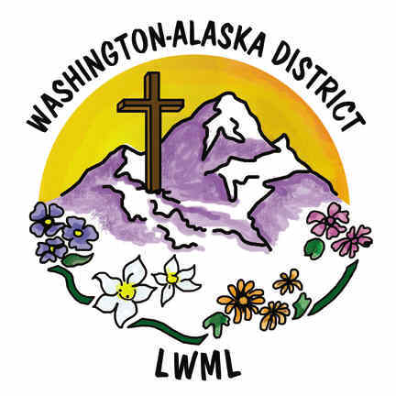
Lutheran Women’s Missionary League
Washington-Alaska District
Short Term Mission
Application and Request for Funds Form
2022-2024 Biennium

Any woman belonging to a church in The Lutheran Church—Missouri Synod in the LWML Washington-Alaska District is invited to apply.

Today’s Date: ____________________________
Name: ____________________________________________________________
Address: __________________________________________________________
Phone: __________________________________
Email address: _____________________________________________________
Communicant member of ______________________________________, LCMS in
City ___________________________________, State ______________________
Mission Name and Location: ___________________________________________
- Description of mission project: ____________________________________
_____________________________________________________________
- I will be participating in: (e.g., leading Bible studies, VBS, building, etc.)
_____________________________________________________________
- Mission Involvement: Start Date: ____________ End Date: ____________
- Itemized cost of mission: $ _______________________________________
_____________________________________________________________
- Provide a list of other sources of money received: $___________________
_____________________________________________________________
- Short Term Mission grant amount requested: $ _______________________
- Please submit a short story of your mission experience, with photos if possible, to the Short Term Missions chair within a month of returning from your trip.

Applicant Signature: __________________________________________________

Pastoral Support Signature: ______________________ _ _

Note: Physical signatures are required (not electronic).

Please return completed form to:
Patrice Cornelius, Short Term Missions Chairman
803 Dayton Drive
Sunnyside, WA 98944
cell phone 509-840-2581
or print, complete, sign, scan, and email to: patrice.cornelius@gmail.com
page 1

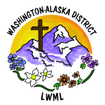
Lutheran Women’s Missionary League
Washington-Alaska District

** This page to be completed by district committee and officers.

Date:

Grant Title: Short Term Mission Grant ____________________________________
Total amount of grant awarded from LWML WA-AK District:
Grant amount payment (check one): the total grant in one payment

Check payable to: __________________________________________________
Mail check to: __________________________________________________
_________________________________________________
______________________________________________________
______________________________________________________

FOR OFFICE USE ONLY

Date received: Date approved:

Signatures: District President

VP of Gospel Outreach

Treasurer

Payment amount:

Payment date:

Page 2

